

**SOFTWARE ENGINEERING**

***MEDICAL CLINIC***

AUTHORS:

Iñaki Seco ; Sefa Kurtoglu

PROFESSORS:

Tadeusz Dyduch ; Małgorzata Żabińska-Rakoczy

09/11/2017

**Table of Contents**

**1. Project description** **2**

1.1 Area and subject of modeling 2

1.1.1 Problem domain 2

1.2 Modeling area 2

1.2.1 Description of organization structure 2

1.2.2 Activity areas 3

1.3 Activity areas’ description 3

1.3.1 Posts description 3

1.3.2 Business procedures description 3

1.4 Verified system’s responsibilities 4

1.5 Short problems 4

1.6 Goals: 4

1.6.1 Product’s aims 4

1.6.2 Design aims 4

**2. Requirements description** **5**

2.1 List of functions from the users’ viewpoint 5

2.2 Data to be stored in the system 5

2.3 Input and output documents 7

2.4 Required special requirements and limitations 7

2.5 Functional requirements’ analysis 8

2.5.1 Patients Module 8

2.5.1 Doctors Module 9

2.5.1 Administrative Module 10

2.6 Functional requirements for additional system functions 11

2.7 Non-functional requirements 11

## 

## 1. Project description

### 1.1 Area and subject of modeling

##### 1.1.1 Problem domain

The company is a medical organization composed of many different employees and created to reach every person that needs medical assistance, so that is the kind of people that are going to be interested on the project.

The software is going to be used in a medical clinic, helping both employees and clients, so for example the patients will be able to ask for a meeting with the doctor when they need medical assistance and doctors will send messages and prescriptions back to the patients.

### 1.2 Modeling area

##### 1.2.1 Description of organization structure

Thanks to our modelling project, the organization of any medical clinic will be extremely easy to administrate. In these systems are going to take part not only the doctors and nurses but also the patients and providers of each office. The

The employees will be able to modified things such important like medical records of theirs patients or diagnostics from the appointments, as well as others less vital stuffs like, for example, holidays and vacations. In addition to that, patients will have the choice to make online appointments in a really simple way.

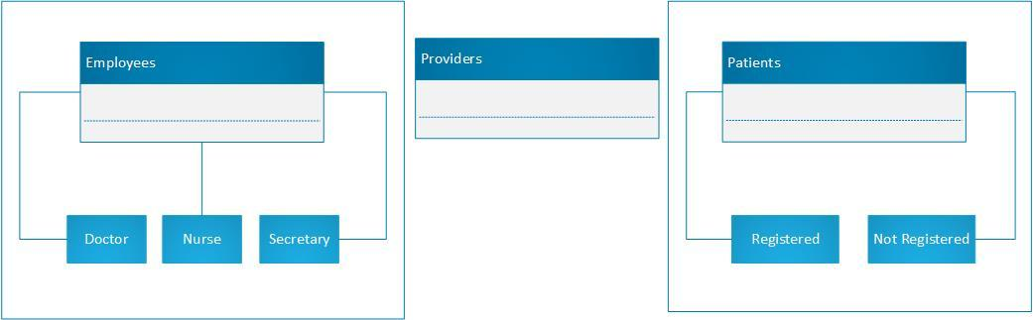

##### 

##### 1.2.2 Activity areas

Each clinic will content the following areas separately:

* Administrative area
* Medical area
* Ordering area
* Human resources

### 1.3 Activity areas’ description

##### 1.3.1 Posts description

* Administrative area:

This area concerns everything what has to do with calendars, payments and identities or information about every individual interact with the clinic. Legal documentations and signed contracts from each person who has work or gain from those services.

* Medical area

The medical records and analyzes belongs to this area, as well as treatments followed by the patients and doctors. This information is quite sensitive due to its delicacy, so it will be specially good protected.

* Ordering area

Here we will include purchases and sales of different products which are necessary for the company. They are going to be mainly medicines and hygiene items for the maintenance of the office and services.

* Human resources

This area will be dedicated to manage the environment between the employees, additionally, they handle all new employees and other kind of internal problems.

##### 1.3.2 Business procedures description

* Administrative area:

The employees in this area participate in a lot of business deals, they have to manage and store every contract done with a client, management of documents and information of the doctors, etc.

* Medical area

There have to be a very good and special business deal on this area with the security of data enterprises, cause here is where the medical data is managed.

* Ordering area

This area is working directly with the providers, making deals and orders every week to have the necessary materials and medicaments for the clinic. Once they have closed a deal they must send the pertinent documents to the administrative area.

* Human resources

Human resources negotiate with the employees their contracts and new salaries, and also are the ones in charge of the new hires and layoffs.

### 1.4 Verified system’s responsibilities

The system must guarantee a fast and good communication between the company and the clients, because patients must need a medical response quickly in case they have a serious health problem.

Also, it must store the medical data of the employees and of the registered clients, but with a very good security system to protect the people personal and medical information and prevent legal problems.

### 1.5 Short problems

One of the biggest problems the system will have to handle with is the unpredictable success of itself, so we will have to work and improve the system in case we have a lot of demand. For example, if we have a lot of registered clients we must store a huge amount of data and also have a better security system.

Another problem could be the fact that older people are less used to using new technologies, so we should implement in a way that everyone find it easy. Also, we could make it more international offering a few options for the language of the system and the communication with the employees.

### 1.6 Goals:

##### 1.6.1 Product’s aims

This product aims are to improve communication between hospital and patients, it will help to direct referrals to other hospital. On the other hand, the product is going to be beneficial for the shipment of medicines and materials.

##### 1.6.2 Design aims

This application is calculated specially to help older people, the design includes a small messaging application so these people will be able to communicate immediately without the needed of going to the hospital.

## 2. Requirements description

### 

### 2.1 List of functions from the users’ viewpoint

* Patients
  + Make an appointment with the doctor
  + View their medical records
* Employees
  + Manage their contract
  + Manage holidays/free days
  + Order products
* Doctors
  + View medical records from their patients
  + Make a diagnosis
  + Add treatments to a patient
* Secretary
  + Add appointments
  + Manage medical records
* Nurse
  + Add treatments (limited)
  + Keep medical records (limited)
* Providers
  + Check their orders

### **2.2 Data to** **be stored in the system**

In the system we will have information about all the people who is related to our clinic, as appointments, diagnosis, but also payments and salaries. To be more concrete:

* Employees
  + Name
  + ID
  + Address
  + Phone number
  + Email address
  + Bank account
  + Status of payment
* Doctors
  + Department number
  + Calendar
  + List of activities
* Nurse
  + Department number
  + List of activities
* Secretary
  + List of activities
* Providers
  + Name
  + ID
  + Address
  + Phone number
  + Email address
  + Department number
  + Type of product
  + List of activities
  + Bank account
* Registered patients
  + Name
  + ID
  + Address
  + Phone number
  + Email address
  + List of activities
  + Status of subscription payment
  + Dates of appointment
* Not registered patients
  + Name
  + Address
  + Phone number
  + Email address
  + Dates of appointment

### 

### 

### **2.3 Input and output documents**

* Registration file

Registration will be an input information. When a new patient wants to subscribe to our medical clinic he has to fill a profile document about himself and his personal information such as full name, home address, phone number, bank account, etc. in order to the secretary can add all this information to the system.

* Doctor’s diagnostics

Doctor’s diagnostics are output documents, these documents include some informations about the patient’s situation. All this diagnostics will be input information for patient’s treatments

* Patient’s treatments

Treatments will be output information as well as input because it would be the doctor's conclusion about the treatment to be followed by a patient, but also would be the document which the respective patient has to check to be able to follow it.

* Calendar

Here we have both type of documents as well. First of all the patient has to be able to see when the doctor is free to get an appointment, this would be output information. But then the patient has to fill a form about the appointment date, reasons and so on, this would be an input document.

### **2.4 Required special requirements and limitations**

The most important thing to consider in our system is to have knowledge about how sensitive are the documents we deal with, in fact, we are talking about completely secret information about people.

That means we need a really secure system which doesn’t let anybody go in without permission. The connections will be especially secure when they talk about diagnostics or reports from the doctors, and the login will be totally controlled, modifying passwords every three months or adding second steps as security improvement.

### 

### 

### **2.5 Functional requirements’ analysis**

The system consists of 3 modules: Patients Module, Doctors Module, Administrative Module. Each module has its own use case diagram and scenarios

##### 2.5.1 Patients Module

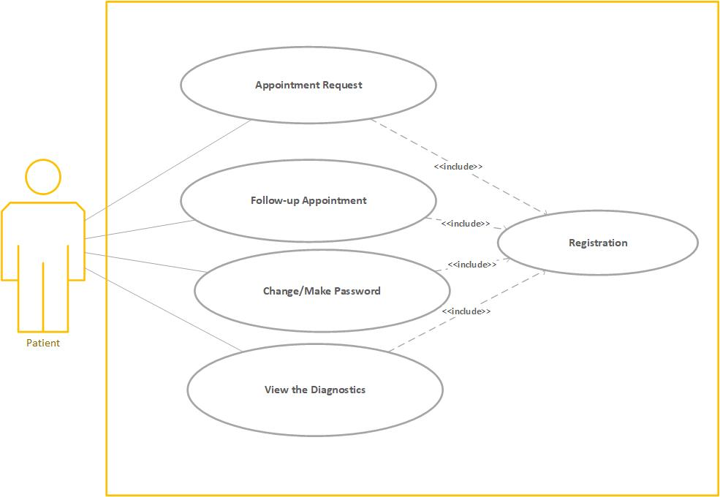

##### 

##### 

##### 2.5.1 Doctors Module

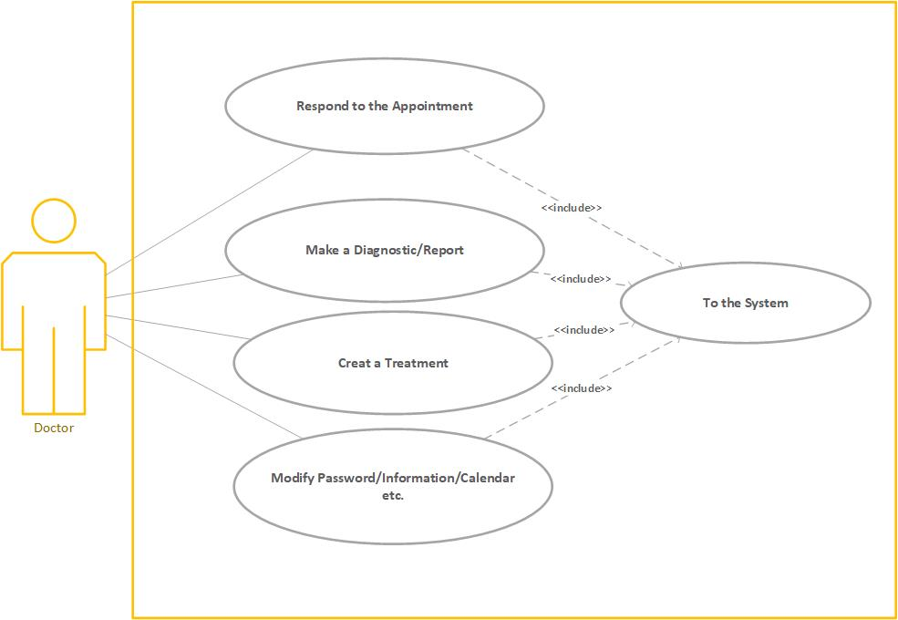

##### 

##### 

##### 2.5.1 Administrative Module

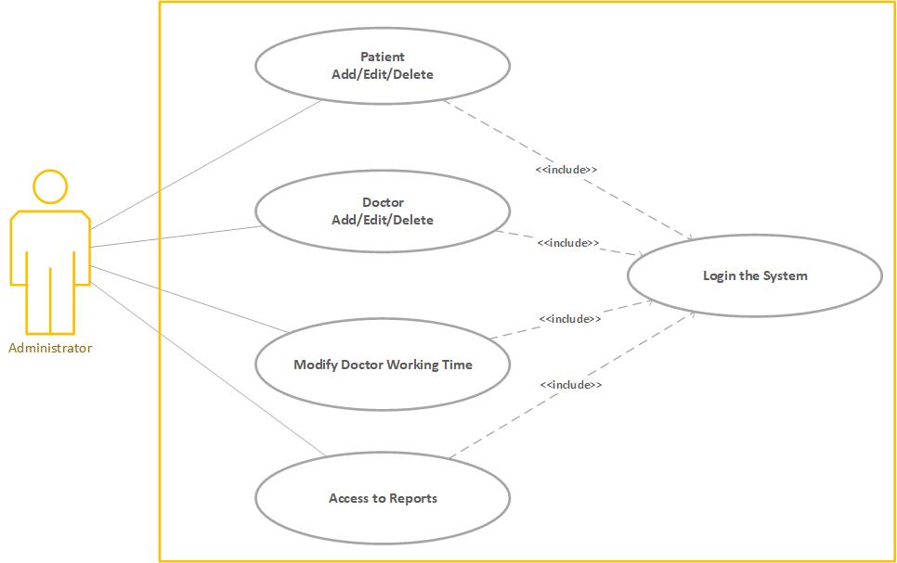

### 

### 

### **2.6 Functional requirements for additional system functions**

We have only three input scenarios: Patients, Doctors and Administrations inputs:

* Patients input
  + Fill the profile form
  + Get an appointment
  + Update information about profile
  + Check the reports from the doctor
* Doctors input
  + Make a diagnostic/report
  + Create a treatment
* Administrative input
  + Add/Delete a new patient to the regist
  + Modify information about the patients
  + Modify the information about employees contracts

### **2.7 Non-functional requirements**

The medical clinic will have next non-functional requirements:

* Update the information about the calendar of the doctors
* Control the amount of patients has each doctor per day
* Get statistics about the procedure and results of the clinic